Step 5)

Project - Walmart.com -> Account

Sign in

Track order

Reorder items

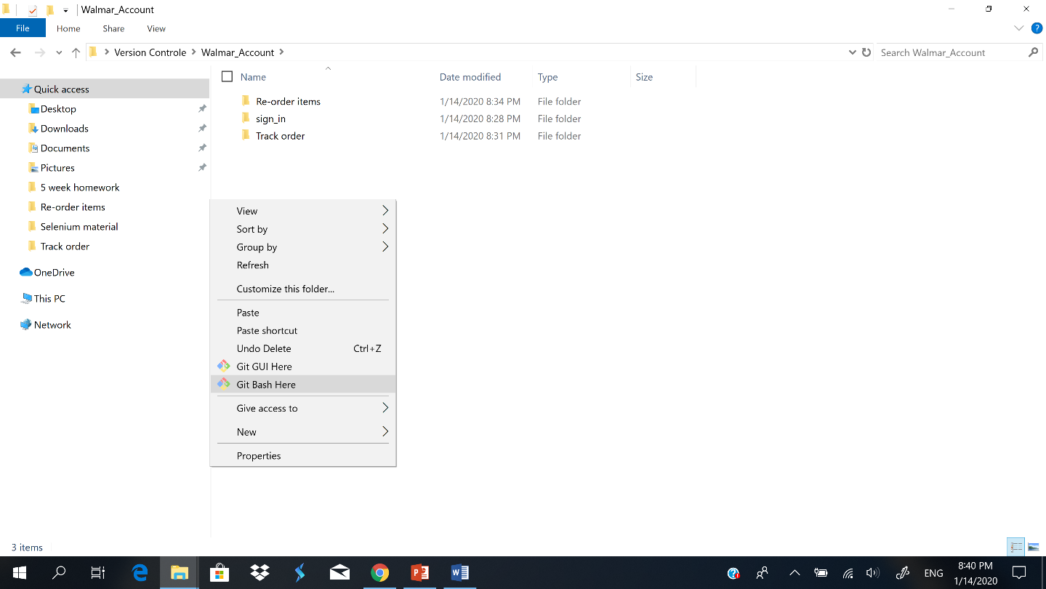Step 6) you have to see Git Bash Here option once you clicked right on inside of folder.

Step 7) how to get all your information from your folder in Git Bash.

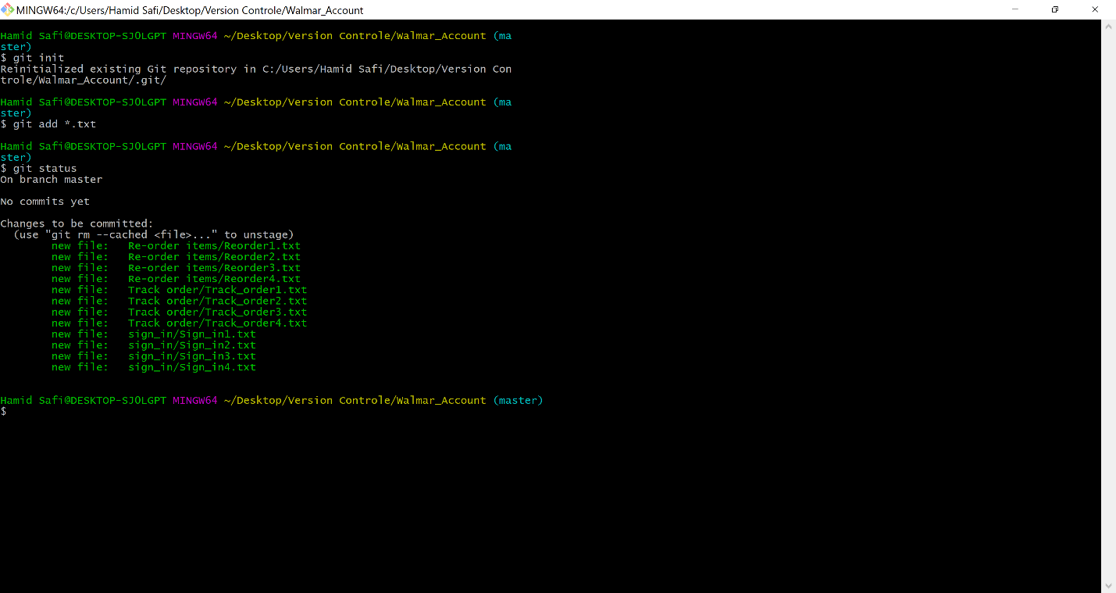

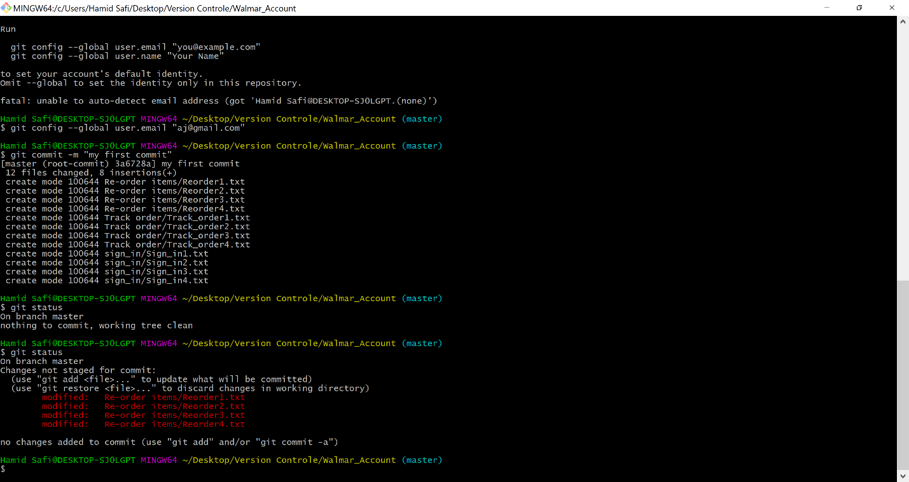Step 8) how to know if you do some changes on any folder

**Git file status life cycle**

Working directory 🡪 ADD 🡪

STAGING AREA > COMMIT 🡪 GIT Local Repository 🡪Push

git remote add origin <https://github.com/hamid3573/test-1.git>

step1 Jira – Task ticket

* Hello world in Java

Step2 Coding – Java/HTML

Step3 Copy /past – in notepad

Step4 Push to GitHub

Hamid Safi@DESKTOP-SJ0LGPT MINGW64 ~/Desktop/Version Controle/Walmar_Account (master)

$ git init

Reinitialized existing Git repository in C:/Users/Hamid Safi/Desktop/Version Controle/Walmar_Account/.git/

Hamid Safi@DESKTOP-SJ0LGPT MINGW64 ~/Desktop/Version Controle/Walmar_Account (master)

$ git add *.txt

Hamid Safi@DESKTOP-SJ0LGPT MINGW64 ~/Desktop/Version Controle/Walmar_Account (master)

$ git status

On branch master

No commits yet

Changes to be committed:

(use "git rm --cached <file>..." to unstage)

new file: Re-order items/Reorder1.txt

new file: Re-order items/Reorder2.txt

new file: Re-order items/Reorder3.txt

new file: Re-order items/Reorder4.txt

new file: Track order/Track_order1.txt

new file: Track order/Track_order2.txt

new file: Track order/Track_order3.txt

new file: Track order/Track_order4.txt

new file: sign_in/Sign_in1.txt

new file: sign_in/Sign_in2.txt

new file: sign_in/Sign_in3.txt

new file: sign_in/Sign_in4.txt

Hamid Safi@DESKTOP-SJ0LGPT MINGW64 ~/Desktop/Version Controle/Walmar_Account (master)

$ git commit -m "my first commit"

*** Please tell me who you are.

Run

git config --global user.email "you@example.com"

git config --global user.name "Your Name"

to set your account's default identity.

Omit --global to set the identity only in this repository.

fatal: unable to auto-detect email address (got 'Hamid Safi@DESKTOP-SJ0LGPT.(none)')

Hamid Safi@DESKTOP-SJ0LGPT MINGW64 ~/Desktop/Version Controle/Walmar_Account (master)

$ git commit -m "my first commit"

*** Please tell me who you are.

Run

git config --global user.email "you@example.com"

git config --global user.name "Your Name"

to set your account's default identity.

Omit --global to set the identity only in this repository.

fatal: unable to auto-detect email address (got 'Hamid Safi@DESKTOP-SJ0LGPT.(none)')

Hamid Safi@DESKTOP-SJ0LGPT MINGW64 ~/Desktop/Version Controle/Walmar_Account (master)

$ git commit -m "my first commit"

*** Please tell me who you are.

Run

git config --global user.email "you@example.com"

git config --global user.name "Your Name"

to set your account's default identity.

Omit --global to set the identity only in this repository.

fatal: unable to auto-detect email address (got 'Hamid Safi@DESKTOP-SJ0LGPT.(none)')

Hamid Safi@DESKTOP-SJ0LGPT MINGW64 ~/Desktop/Version Controle/Walmar_Account (master)

$ git config --global user.email "aj@gmail.com"

Hamid Safi@DESKTOP-SJ0LGPT MINGW64 ~/Desktop/Version Controle/Walmar_Account (master)

$ git commit -m "my first commit"

[master (root-commit) 3a6728a] my first commit

12 files changed, 8 insertions(+)

create mode 100644 Re-order items/Reorder1.txt

create mode 100644 Re-order items/Reorder2.txt

create mode 100644 Re-order items/Reorder3.txt

create mode 100644 Re-order items/Reorder4.txt

create mode 100644 Track order/Track_order1.txt

create mode 100644 Track order/Track_order2.txt

create mode 100644 Track order/Track_order3.txt

create mode 100644 Track order/Track_order4.txt

create mode 100644 sign_in/Sign_in1.txt

create mode 100644 sign_in/Sign_in2.txt

create mode 100644 sign_in/Sign_in3.txt

create mode 100644 sign_in/Sign_in4.txt

Hamid Safi@DESKTOP-SJ0LGPT MINGW64 ~/Desktop/Version Controle/Walmar_Account (master)

$ git status

On branch master

nothing to commit, working tree clean

Hamid Safi@DESKTOP-SJ0LGPT MINGW64 ~/Desktop/Version Controle/Walmar_Account (master)

$ git status

On branch master

Changes not staged for commit:

(use "git add <file>..." to update what will be committed)

(use "git restore <file>..." to discard changes in working directory)

modified: Re-order items/Reorder1.txt

modified: Re-order items/Reorder2.txt

modified: Re-order items/Reorder3.txt

modified: Re-order items/Reorder4.txt

no changes added to commit (use "git add" and/or "git commit -a")

Hamid Safi@DESKTOP-SJ0LGPT MINGW64 ~/Desktop/Version Controle/Walmar_Account (master)

$ git add *.txt

Hamid Safi@DESKTOP-SJ0LGPT MINGW64 ~/Desktop/Version Controle/Walmar_Account (master)

$ git commit -m "my second commit"

[master 31f3ece] my second commit

4 files changed, 4 insertions(+), 4 deletions(-)

Hamid Safi@DESKTOP-SJ0LGPT MINGW64 ~/Desktop/Version Controle/Walmar_Account (master)

$ git status

On branch master

nothing to commit, working tree clean

Hamid Safi@DESKTOP-SJ0LGPT MINGW64 ~/Desktop/Version Controle/Walmar_Account (master)

$ ^C

Hamid Safi@DESKTOP-SJ0LGPT MINGW64 ~/Desktop/Version Controle/Walmar_Account (master)

$ git remote add origin https://github.com/hamid3573/test-1.git

Hamid Safi@DESKTOP-SJ0LGPT MINGW64 ~/Desktop/Version Controle/Walmar_Account (master)

$ git puch -u origin master

git: 'puch' is not a git command. See 'git --help'.

The most similar command is

push

Hamid Safi@DESKTOP-SJ0LGPT MINGW64 ~/Desktop/Version Controle/Walmar_Account (master)

$ git puch -u origin master

git: 'puch' is not a git command. See 'git --help'.

The most similar command is

push

Hamid Safi@DESKTOP-SJ0LGPT MINGW64 ~/Desktop/Version Controle/Walmar_Account (master)

$ git push -u origin master

Enumerating objects: 15, done.

Counting objects: 100% (15/15), done.

Delta compression using up to 8 threads

Compressing objects: 100% (8/8), done.

Writing objects: 100% (15/15), 958 bytes | 239.00 KiB/s, done.

Total 15 (delta 0), reused 0 (delta 0)

To https://github.com/hamid3573/test-1.git

* [new branch] master -> master

Branch 'master' set up to track remote branch 'master' from 'origin'.

Hamid Safi@DESKTOP-SJ0LGPT MINGW64 ~/Desktop/Version Controle/Walmar_Account (master)